7 Effective Formative Assessment: Meaning, Types & Examples

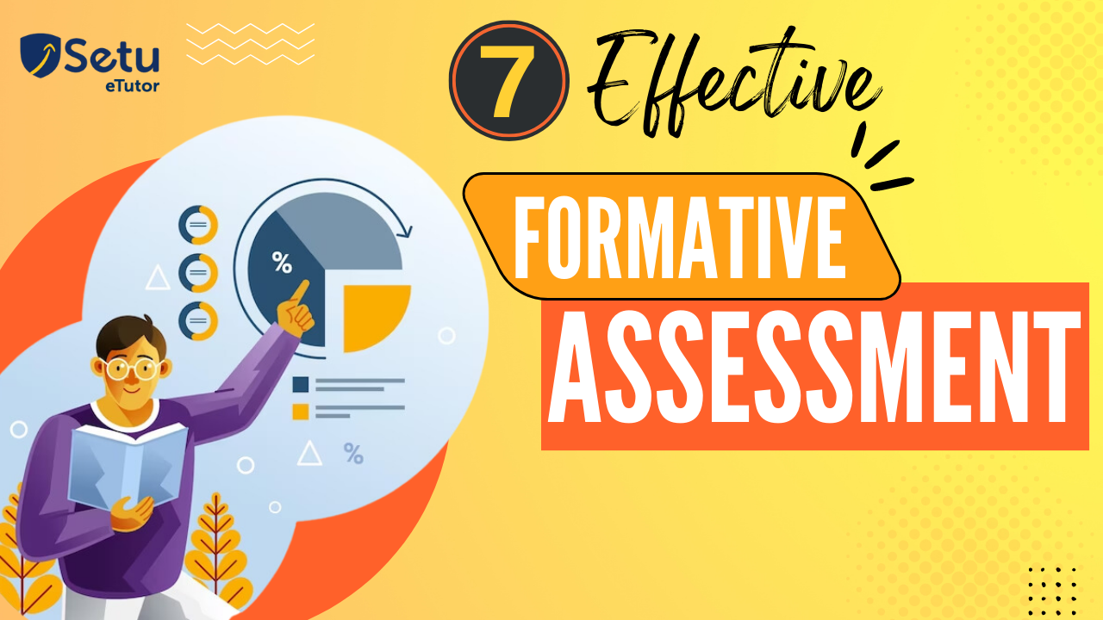

7 Effective Formative Assessment: Meaning, Types & Examples

Table of contents

* [What is Formative Assessment?](https://setu.etutor.co/blog/formative-assessment/#What_is_Formative_Assessment)
* [What are the types of formative assessment?](https://setu.etutor.co/blog/formative-assessment/#What_are_the_types_of_formative_assessment)
* [What is formative vs summative assessment?](https://setu.etutor.co/blog/formative-assessment/#What_is_formative_vs_summative_assessment)
* [Examples of Formative and Summative Assessments](https://setu.etutor.co/blog/formative-assessment/#Examples_of_Formative_and_Summative_Assessments)
* [Conclusion](https://setu.etutor.co/blog/formative-assessment/#conclusion)

Evaluating the student’s learning needs at any point of learning is pivotal for teachers. Such type of analysis or evaluation is done through the **formative assessment**. [National Education Policy](https://setu.etutor.co/blog/national-education-policy/)(NEP) 2020 recommends formative assessments in practice sessions since they contribute to the overall**holistic development of the students.**

**Formative Assessments**

The [National Education Policy (NEP) 2023](https://setu.etutor.co/national-education-policy-2023) encourages a shift in assessment practices to ensure a comprehensive evaluation and bridge students’ learning gaps to meet 21st-century skills.

Unlike summative assessment, which occurs at the end of a unit or course to measure overall learning, formative assessment is ongoing. It focuses on providing feedback to students and teachers to **improve learning outcomes.**

It helps **identify the student**[learning gaps](https://setu.etutor.co/blog/learning-gaps/)**, informs instructional decisions**, and supports students’ growth.

**Types of Formative Assessments**

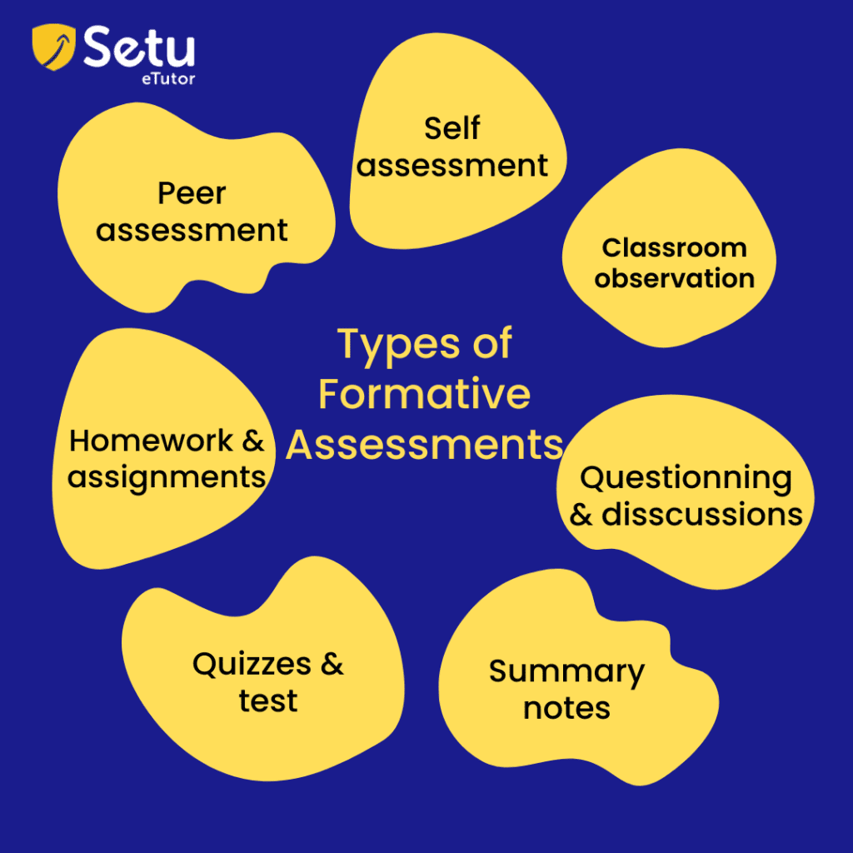

When discussing the types of formative assessments, a myriad of assessments come under this roof. They are:

1. **Classroom Observation:** Teachers observe s**tudents’ behavior, interactions, and engagement** in class to assess their understanding and progress.
2. **Questioning and Discussion:** Teachers ask questions during class discussions to **gauge students**‘ comprehension and encourage critical thinking.
3. **Summary Notes:** Brief assessments are given at the end of a class or lesson to assess students’ understanding of the material covered.
4. **Quizzes and Tests:** **Short quizzes or mini-tests**conducted during or after a lesson to assess understanding and identify misconceptions.
5. **Homework and Assignments:** Assignments are given for **practice or reinforcement**, which provide insights into students’ grasp of concepts.
6. **Peer Assessment:** Students evaluate and provide feedback on each other’s work, **promoting self-assessment and collaboration.**
7. **Self-Assessment:** Students reflect on their learning, **set goals, and evaluate their progress, fostering metacognitive skills.**

In sync with[NEP 2023](https://setu.etutor.co/national-education-policy-2023)vision, SETU integrates these formative assessments into its platform. These assessments help schools, teachers, and students improve their entire teaching and learning process.

I am sure you are very clear about formative assessment and its types.

Next, we will discuss the key **difference between formative and summative assessments.**

**Formative Assessment vs Summative Assessment**

The key difference between formative assessment and summative assessment are:

| **Difference** | **Formative Assessments** | **Summative Assessments** |
| --- | --- | --- |
| Purpose | Monitor students' learning progress during the instructional process | Evaluate students' learning achievement at the end of a unit, course, or instructional period |
| Timing | Occurs throughout the learning process | Administered at the end of a semester, course, or academic year. |
| Focus | Identifying students' strengths and weaknesses, promoting self-reflection, and informing instructional decisions to support continuous improvement. | Extent of achieving the student learning outcomes or standards set for the course or curriculum |
| Feedback Mechanism | Immediate or timely feedback to students, enabling them to understand their progress | Provides feedback to students but often with less immediacy compared to formative assessment. |
| Cumulative Evaluation | Support learning rather than determine overall achievement. | Serves as a culmination of learning and determines students' overall achievement. |

**Examples of formative and summative assessments**

The below-illustrated examples serve different purposes and **contexts of formative and**[summative assessments](https://en.wikipedia.org/wiki/Summative_assessment)**.** Formative assessments are designed to provide ongoing feedback and support learning, while summative assessments are typically used to evaluate overall achievement and determine grades or certifications.

**Examples of Formative Assessments:**

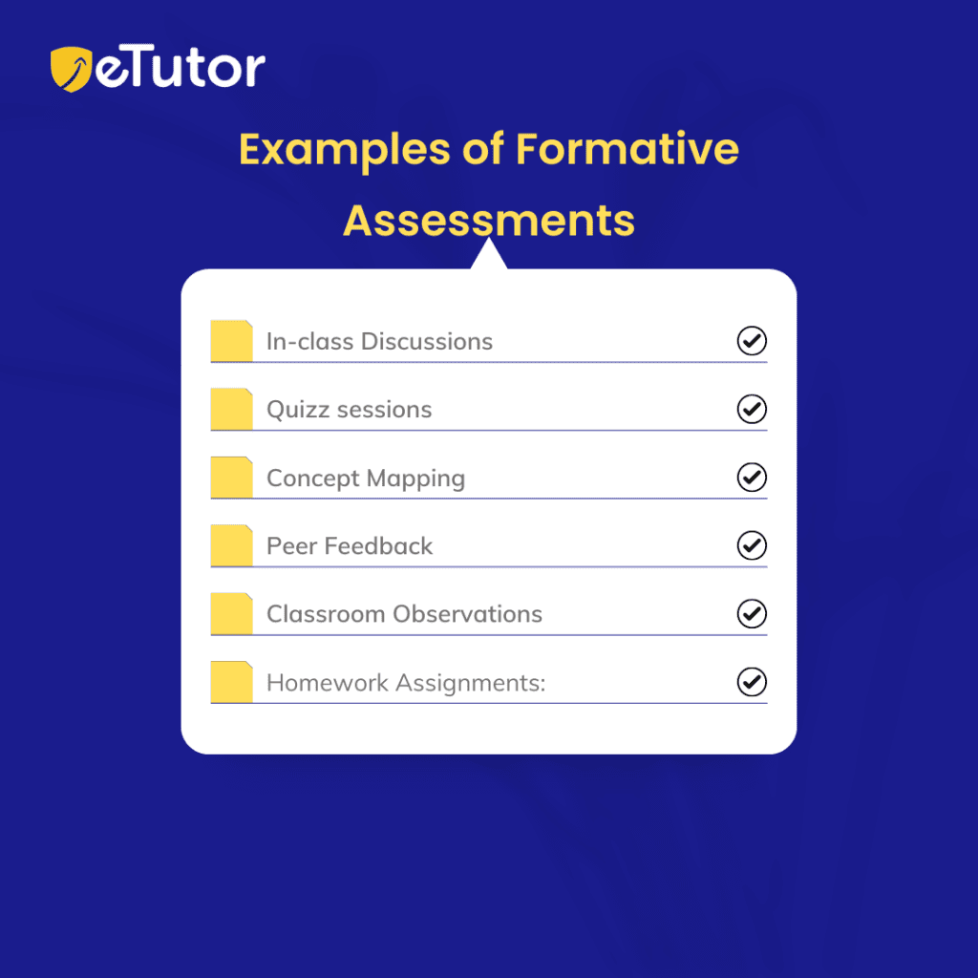

* **In-class Discussions:**Engaging students in discussions to assess their understanding of a topic and promote **critical thinking.**
* **Quizz sessions:** Quick quizzes or short written responses at the end of a lesson to gauge students’ comprehension.
* **Concept Mapping:** Asking students to**create visual diagrams** that represent their understanding of the relationships between concepts.
* **Peer Feedback:**Having students provide constructive feedback to their peers on projects or presentations.
* **Classroom Observations:**Teachers observing students’ behavior, participation, and engagement during class activities.
* Homework Assignments: Assigning practice problems or tasks that allow teachers to **gauge students’ understanding and identify areas for improvement.**

**Examples of Summative Assessments:**

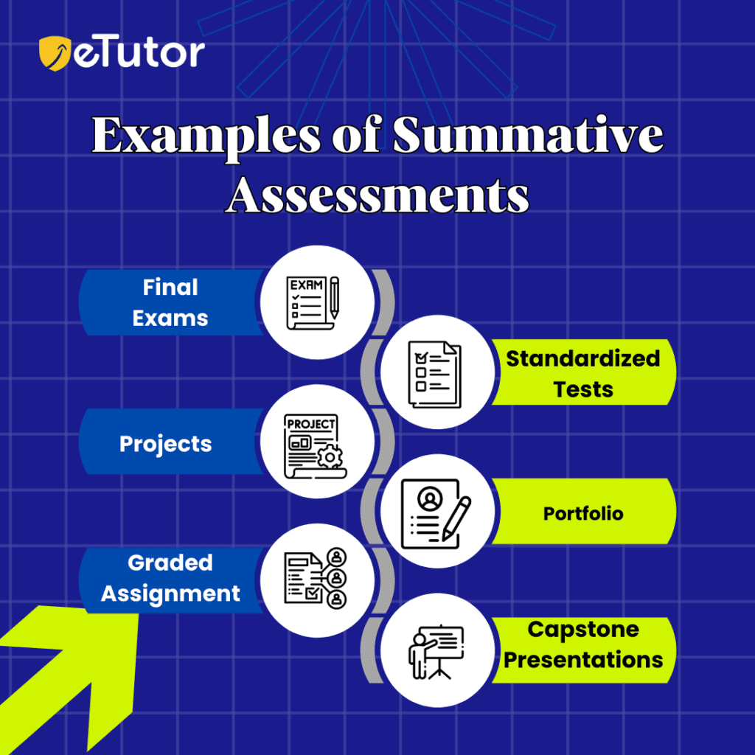

* **Final Exams:**Comprehensive exams administered at the end of a course or academic year to evaluate **overall knowledge and understanding**.
* **Standardized Tests:** Assessments designed to measure students’ proficiency in specific subjects are often used for comparative purposes.
* **Projects:** Longer-term projects demonstrate students’ ability to apply knowledge and skills acquired throughout a course.
* **Portfolios:** Collections of student work, such as **essays, projects, or presentations**, are compiled to showcase their achievements and progress over time.
* **Graded Assignments:** Assignments or assessments that are scored and contribute to students’ final grades, such as essays or lab reports.
* **Capstone Presentations:** Final presentations where students showcase their knowledge, skills, and accomplishments in a specific area of study.

**How does SETU help to conduct Formative Assessments?**

SETU can play a significant role in collecting student feedback, allowing instructors to refine their formative assessment practices and create a more effective and engaging learning environment.

* The **feedback mechanism** helps teachers gauge how well their instructional methods facilitate student learning and adjust accordingly.
* SETU helps in determining the **student’s engagement level during instructional activities and assessments.**
* By identifying Strengths and Weaknesses, teachers adjust their instructional approaches, **provide targeted support**, and **design effective formative assessments to address areas where students may struggle.**
* Overall by analyzing the feedback data, our SETU platform helps **continuously refine formative assessment practices.**

Conclusion:

Formative assessment positively impacts the entire **teaching and learning process**. Teachers use the data to **improve their teaching methods, and students can identify areas of improvement**and highlight areas where they need help.

Tags: [360-degree holistic development](https://setu.etutor.co/blog/tag/360-degree-holistic-development/), [bridging learning gaps](https://setu.etutor.co/blog/tag/bridging-learning-gaps/), [computational thinking](https://setu.etutor.co/blog/tag/computational-thinking/), [experiential learning](https://setu.etutor.co/blog/tag/experiential-learning/), [learning outcomes](https://setu.etutor.co/blog/tag/learning-outcomes/), [mathematical thinking](https://setu.etutor.co/blog/tag/mathematical-thinking/), [NEP 2020](https://setu.etutor.co/blog/tag/nep-2020/), [NEP 2020 Key Themes](https://setu.etutor.co/blog/tag/nep-2020-key-themes/)

Bottom of Form